**UNIVERSIDAD AUTONOMA DE COAHUILA**

**CENTRO DE IDIOMAS UNIDAD PIEDRAS NEGRAS**

**LINK IT 2B**

**LEVEL 4**

**2ND EXAM**

**STUDENT’S NAME: ____________________________________ DATE: ________________**

**TEACHER’S NAME: ____________________________________**

**PART I. VOCABULARY (15 points)**

Match the pictures with the words in the box. Write the letter (A–F).

|  |
| --- |
| (**A**) scooter (**B**) truck(**C**) ~~bicycle~~ (**D**) bus (**E**) ferry (**F**) taxi |

|  |  |  |  |
| --- | --- | --- | --- |
|  | [ C ] |  | **3** [ ] |
|  | **1** [ ] |  | **4** [ ] |
|  | **2** [ ] |  | **5** [ ] |

Reorder the letters to make types of food.

**1** sfih ________________

**2** efbe________________

**3** ambl ________________

**4** soonin ________________

**5** cleetut ________________

2 Complete the food words.

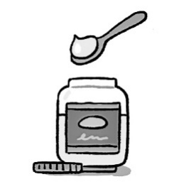

**1** s________t **2** m__________e

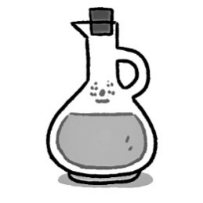

**3** m________d **4** o________eo________l

**5** k________p **6** p________r

**PART II. GRAMMAR (15 points)**

Complete the sentences with *must* or *mustn’t* and the verbs in parentheses.

**1** You _____________ your passport at passport control. (show)

**2** Come on! Quick! We _____________ late. (be)

**3** Stop! You ______________ in that room! (go)

**4** You ______________ with a black pen. Don’t use a blue pen. (write)

**5** Be quiet! You ______________ in the reading test. (talk)

___ / 5

3 Complete the sentences with *mustn’t*,   
*don’t have to*, or *doesn’t have to*.

**1** You __________________ play soccer here. The sign says “No ball games.”

**2** I’m happy because I ________________ get up early tomorrow.

**3** Billy! You ________________ eat that! It’s dirty!

**4** I __________________ be late for school   
again today!

**5** Sally ________________ wear glasses. Her eyes are fine.

Complete the sentences with the words in the box.

many many much much a lot of

**1** She eats __________ fruit.

**2** There isn’t __________ salt on these fries.

**3** How __________ books are in your bag?

**4** Did you see __________ interesting things   
on vacation?

**5** How __________ water do you want?

**PART III. LISTENING (5 points)**

T03 Listen and choose the correct alternatives.

**1** **Some people travel** / **Nobody** **travels** by subway in San Francisco.

**2** Dan enjoys **walking** / **traveling by taxi**.

**3** Mia doesn’t **mind** / **like** cleaning her room.

**4** Mia **has to** / **wants to** go to San Francisco   
again next summer.

**5** Mia **needs** / **doesn’t want** to start her project

**PART IV. READING (5 points) points)COMPREHENSION**

**Read the text. Then do the exercises.**

We had to learn the camp rules. We mustn’t go into the forest without telling someone,   
we have to clean our rooms every morning before breakfast, we mustn’t leave trash anywhere, and we have to go to bed at 9:00 p.m.

There are lots of fun activities, like swimming, bike riding, and playing games. Everybody has to do two morning activities and one afternoon activity every day. But right now   
(4:30 p.m.–5:30 p.m.) it’s “free time” and I don’t have to do anything, so I can write   
this blog on my phone.

Tomorrow we’re learning survival skills. Then, on Friday, we don’t have to go to bed at 9:00 p.m. because we’re going on a night hike. We have to build a shelter outdoors, make a fire, cook together, and then sleep in the shelter. Awesome!

Are these the rules at Ryan’s summer camp? Check (✓) or put a 🗶.

Everyone must learn the camp rules. [ ✓ ]

**1** Are you planning to go into the forest? You must tell someone. [ ]

**2** You don’t have to clean your room every day. [ ]

**3** You don’t have to do anything at five o’clock. [ ]

**4** You mustn’t use your phone. [ ]

**5** You must go to bed at 9:00 p.m. on Friday night. [ ]

**PART V. WRITING (10 points)**

A British friend, Alex, is coming to visit your country in May. Write an email to Alex about the rules, the weather, and customs in your country.

Dear Alex,

_________________________________________

_________________________________________

_________________________________________

_________________________________________

_________________________________________

_________________________________________

_________________________________________

_________________________________________

_________________________________________

_________________________________________

_________________________________________

_________________________________________

_________________________________________

_________________________________________

_________________________________________

_________________________________________

_________________________________________

_________________________________________